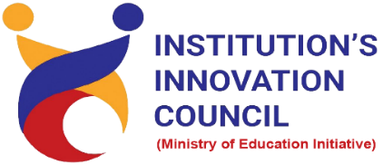

Building Entrepreneurs for future

21 August 2022
At
Seminar hall, Department of Pharmacy
Saurashtra University Campus, Rajkot
Contents
Saurashtra University – IIC 2
Event Schedule 2
Event Registration Link 2
Brief about Event 3
Key Points 3
Outcome 3
Connect Us: 5

Saurashtra University – IIC
The university is dedicated to instruction, research, and extending knowledge to the public (public service). Ministry of Education (MoE), Govt. of India has established ‘MoE’s Innovation Cell (MIC)’ to systematically foster the culture of Innovation among all Higher Education Institutions (HEIs). The primary mandate of MIC is to encourage, inspire and nurture young students by supporting them to work with new ideas and transform them into prototypes while they are informative years. Saurashtra University is one the Organization that have constituted the IIC to foster the vision of MoE and be a part for the promotion and development of innovation ecosystem.

Event Schedule

Event Registration Link

bit.ly/SUSEC-ENT

Brief about Event

We had celebrated World Entrepreneurs Day- 21 August 2022 by organizing a session on "Building Entrepreneurs for future". Students of Saurashtra University from department of Pharmacy participated and celebrated world entrepreneurs’ day enthusiastically.
Entrepreneurship makes you aware of the beautiful reality of what you are capable to achieve and how it can positively impact your life was made understood in this one-day workshop. The purpose of World Entrepreneurs' Day is to create awareness for entrepreneurship, innovation, and leadership among the students.
Entrepreneurs play a major role in an economy by ushering in new ideas and innovation to the market and thereby creating value for their stakeholders and generating jobs.

Key Points

During the session, below mentioned points were discussed:
- Importance of entrepreneur day
- What are the qualities of entrepreneur
- 7 skills of an entrepreneur
- Benefits of entrepreneurship to society
- Importance of entrepreneurship to the economy
- Entrepreneurs’ issues
- FAQs related to Building Entrepreneurs for future

Outcome

As per the event, various types of entrepreneurs’ issues and how to solve it was made understood in this workshop. Students learn a lot about how to start new business and what are the factors influence to the new business.

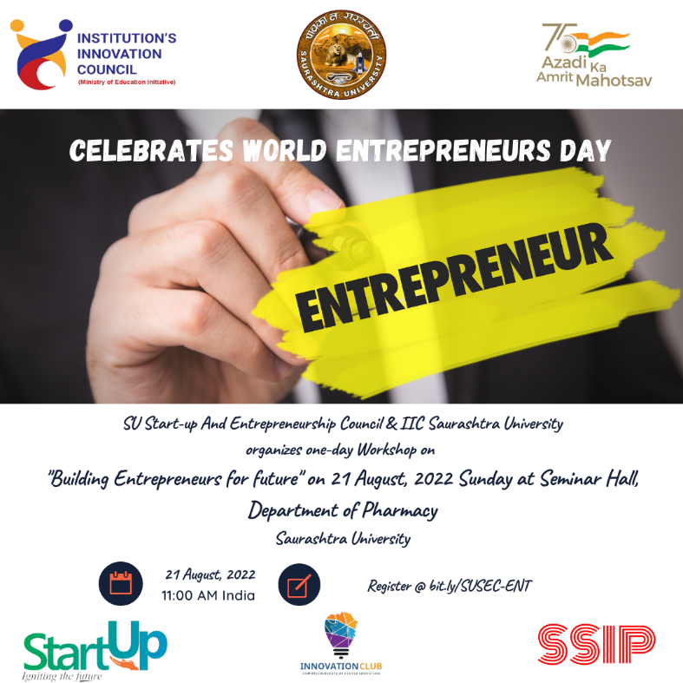

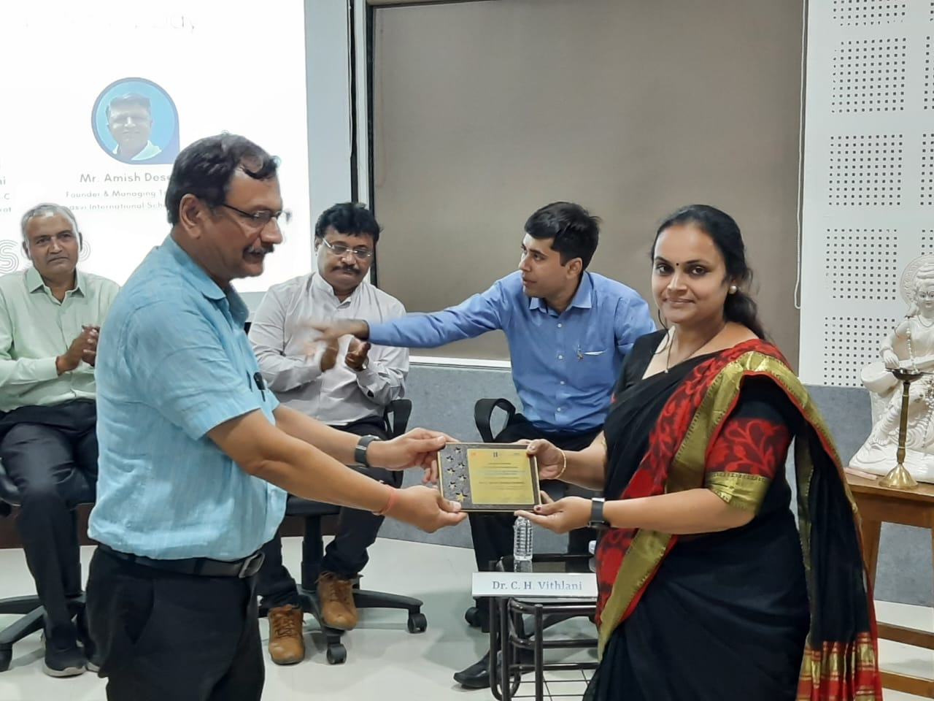
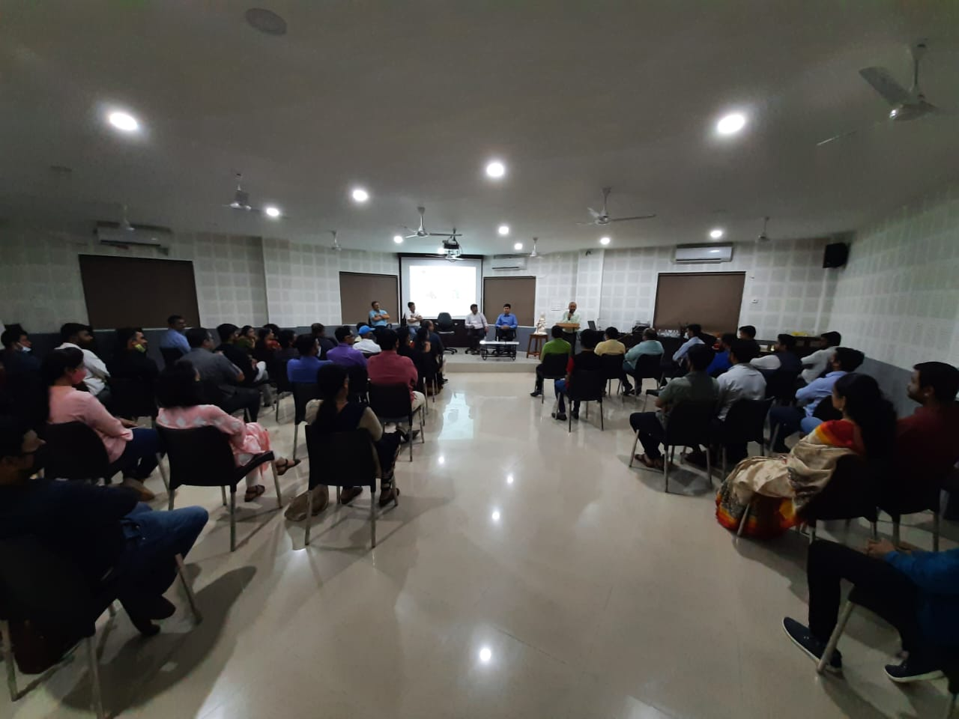

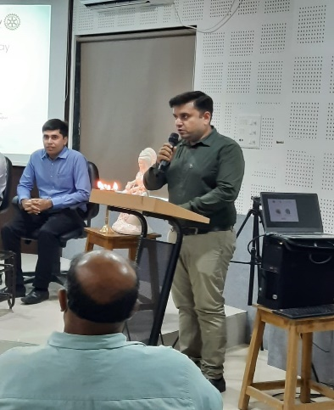
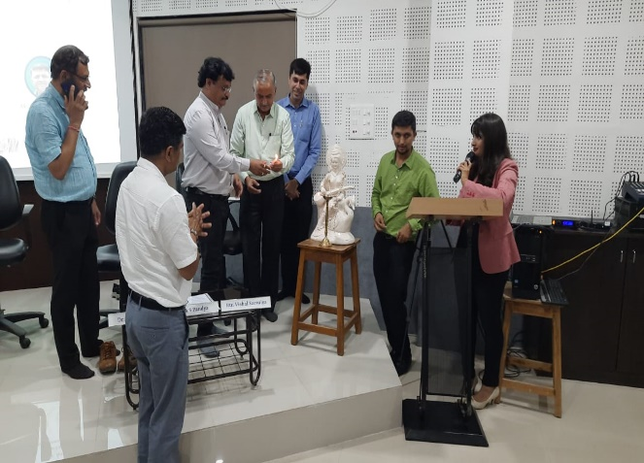
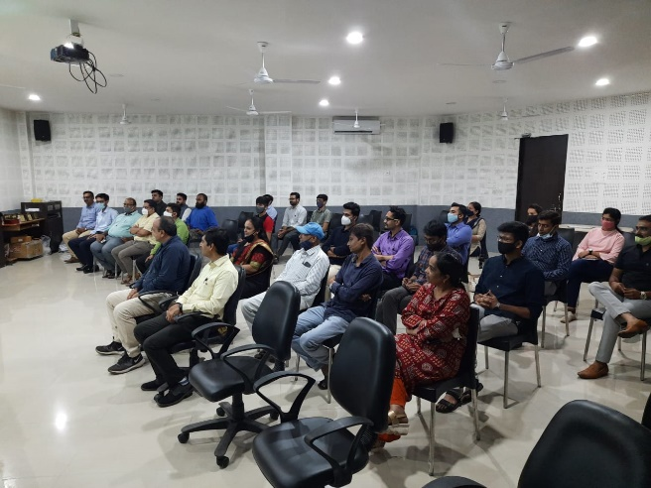

Connect Us:

https://www.linkedin.com/company/susec iic@sauuni.ac.in
https://www.facebook.com/iicsauuni bit.ly/SU-SSIP Location
https://www.instagram.com/susecrajkot https://bit.ly/SUSEC-youtube

